Log on to website: https://www.myodp.org/

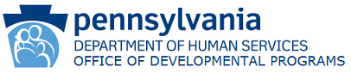

MyODP
Training & Resource Center

Login or Register
Create New Account

- When creating a new account, you will need to pick a username and password and fill in the other required fields.
- ODP will then send you an e-mail. Click on the link in the e-mail
- You will then need to fill in required fields: for Role pick- professional, pick- provider Direct Support Professional, select radial button for- Intellectual Disabilities Services, type in- Human Resources Center Inc. and then Submit
You should be able to login now.
Click Training Tab for a drop-down Menu
Pick “Medication Administration”
Select Training for: Modified Medication Administration Training Course
Complete the 11 sections with quizzes
Pass the Post Test
Print out Certificate and send it to your Program Specialist

This training is for Home Based Waiver DSPs or Life Sharing Providers who need to give Medication to the individual they support.( Individual who is unable to “Self-Administer”)

