Project SEARCH Kalahari Resorts & Conventions – Poconos
FACT SHEET
What is Project SEARCH?
- One year transition program which provides training and education leading to competitive employment for individuals with disabilities.
- The program occurs on-site at a business which has the commitment to support people with disabilities in the workplace.
- Assists young adults with disabilities in making a successful transition from school to working and living a productive adult life.
Program Description:
- One-year program
- Up to 12 student interns per school year
- Students with a variety of disabilities, who are in their last year of high school eligibility
- Rotation through unpaid internships at Kalahari with continual feedback
- Employment in an integrated environment
- Graduation with a formal ceremony
- Outcome of competitive employment
Key Ingredients of Internships: | Sample Project SEARCH Day:
- Internships are the cornerstone of the Project SEARCH program | - 8:30 Arrival, Plan for Day, review Daily Gazetti (Kalahari Newspaper)
- Interns learn competitive, marketable, and transferable employment skills | - 9:30 Report to departments and participate in internships
- Interns participate in training approximately 5 hours per day | - 12:00 Lunch Break
- Interns have the opportunity to develop work and social skills in a natural environment | - 12:30 Return to departments and continue internships
- Each internship lasts approximately 10 weeks | - 2:00 Review day’s activities, Group instructional time to focus on curriculum and employability skills, and communication among all team members
- Evaluation is ongoing | - 3:15 Depart Kalahari
Potential Internship Areas at Kalahari
Administration:  Filing  Mail Distribution  Inventory | Water Park/ Theme Park:  Slide & Ride Attendants  Cabana Stocking  Towel Distribution  Moving Trash
Rooms Division:  Concierge  Door/ Bell Person  Common Area Cleaning  Room Cleaning/ Housemen  Sorting/ Stocking Carts  Laundry  Linen Sorting | Food & Beverage:  Busing Tables  Food Runner  Hosting  Buffet Decorating  Banquet Set-up  Audio/Visual Set-up
Spa:  Spa Attendant | Information Technology (IT):  IT Assistant
Retail:  Retail Cashier  Inventory Management | Receiving:  Receiving  Distribution
Internships are based upon:
- Intern’s interests and skill sets; team input
- Kalahari understands and can accommodate various personalized needs

Eligibility Guidelines and Requirements:
- Applicant must be 18–21 year old students with disabilities enrolled in school-age programming.
- Applicant must be entering his/her last year of high school and/or all high school credits completed.
- Applicant must exhibit appropriate hygiene, social, and communication skills.
- Applicant must have the ability to take direction and change behavior.
- Applicant must have access to reliable transportation and willingness to use independent transportation options.
- Applicant must establish OVR Eligibility.
- Applicant must secure a current PA State ID and possess an original Social Security Card.
- Applicant must be willing to complete and pass background checks.
- Applicant must enroll with County Mental Health/Developmental Services, if eligible.
- Applicant must have the desire to work and become competitively employed!
Student Application Highlights:
- February 11, 2023: Applications are due. Applications received after the due date will also be considered until the Intern Class of 2024 is full.
- March/April:
  - Interview team reviews applications
  - Selected applicants are scheduled for in-person interviews
  - Project SEARCH interns are selected and notified of acceptance
  - OVR eligibility is confirmed
- May/June: Introductory meeting for new interns & complete program entrance requirements
- August: Informational meeting/ orientation for new interns and families
- Early October: IEP Meetings held for each intern

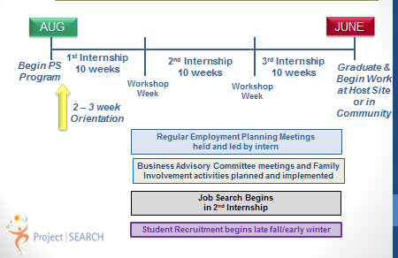

Project SEARCH Kalahari – Partners’s Contact List

 | Contact Person(s): | Phone Number: | Email:
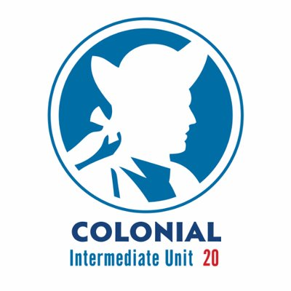  Colonial Intermediate Unit 20 | Brooke Tesche, Supervisor of Special Education | (610) 515-6539 | btesche@ciu20.org
 | Jennifer Jones-Baur, Transition Program Specialist | (610) 515-6456 | jjonesbaur@ciu20.org
 | Mason Messinger, Project SEARCH Instructor | (570) 580-6000  ext 21079 | mmessinger@ciu20.org
 | Michelle Felloni, CIU20 Skills Trainer | (570) 580-6000  ext 21079 | mfelloni@ciu20.org
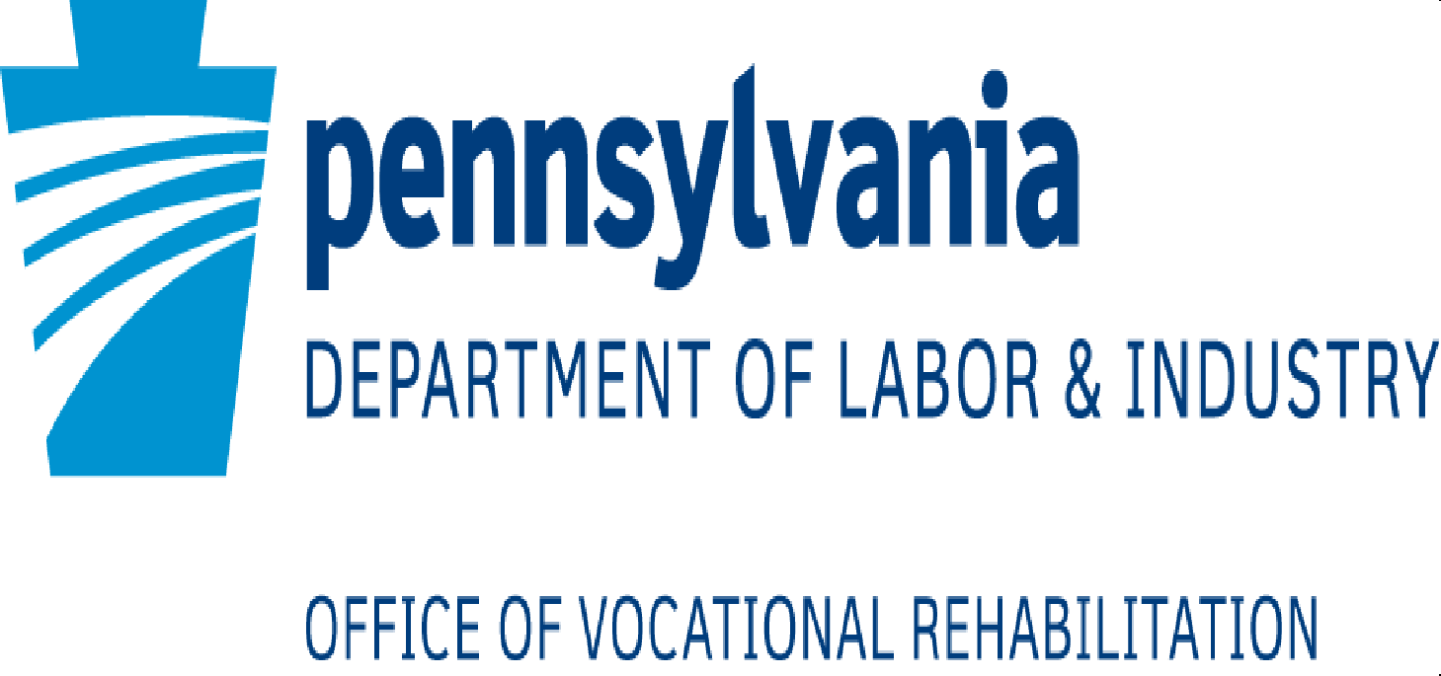  Allentown OVR | Cherrell Gaynor, Supervisor of Transition Services | (610) 821-6593 | cgaynor@pa.gov
 | Cassandra LaVenture, Transition Counselor | (570) 234-1001 | claventure@pa.gov
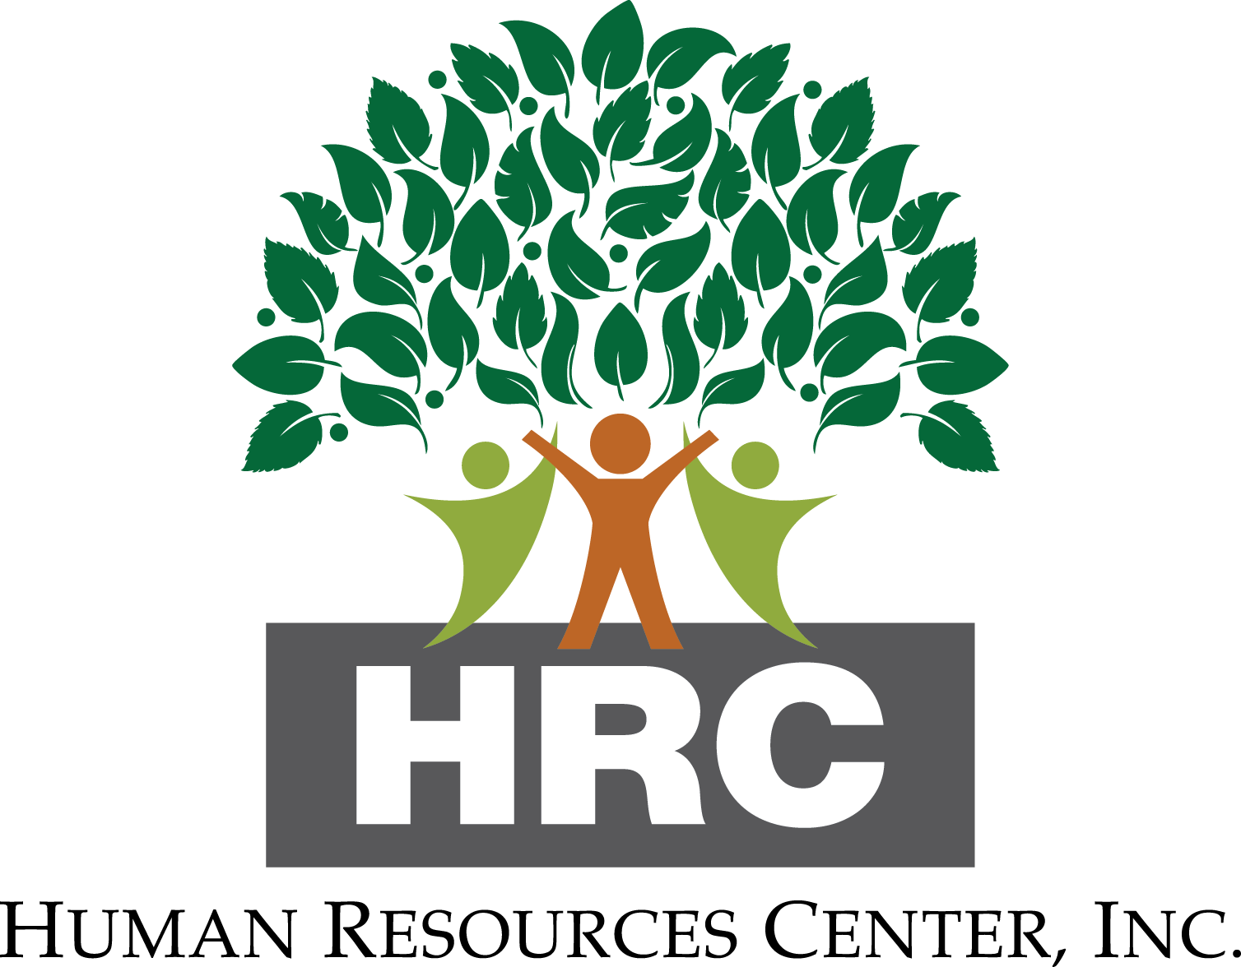 | Dawn Daignault, Director of Community Integrated Employment | (570) 872-9956,  Ext. 304 | Dawn.Daignault@hrcinc.org
 | Jessica Tierney, HRC Job Developer/ Skills Trainer | (570) 229-5730 | Jessica.Tierney@hrcinc.org
Carbon-Monroe-Pike MH/DS | James Furiosi, Quality Manager | (570) 420-1900,  Ext. 3434 | jfuriosi@cmpmhds.org
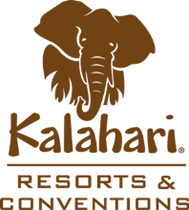  Kalahari - Poconos | Diana Stanukenas, HR Manager/ Point Person for Project SEARCH | (570) 580-6000 | dstanukenas@kalahariresorts.com

